Connections Formative Worksheet

Name________________________
- Choose 4 texts
The 4 texts and authors/directors I will be using are (write one in each box):

- Choose Connection Method
The connection(s) I will be making are (add details):

Character______________________________________________________________________________________

Theme ________________________________________________________________________________________

Setting________________________________________________________________________________________

- Choose Analysis Approach
The aspects I am thinking of analysing for this assessment are:
List the film techniques _________________________________________________________________________
_____________________________________________________________________________________________
_____________________________________________________________________________________________

List the language features _______________________________________________________________________
_____________________________________________________________________________________________
______________________________________________________________________________________________

List the writing style (structure, style, mood, tone etc) _________________________________________________
______________________________________________________________________________________________
______________________________________________________________________________________________

- Develop Ideas Using A Concept Frame (based on your connection @ 1)
Complete at least 3 bullet points in each box in relation to the idea you are making a connection about. An example is provided.
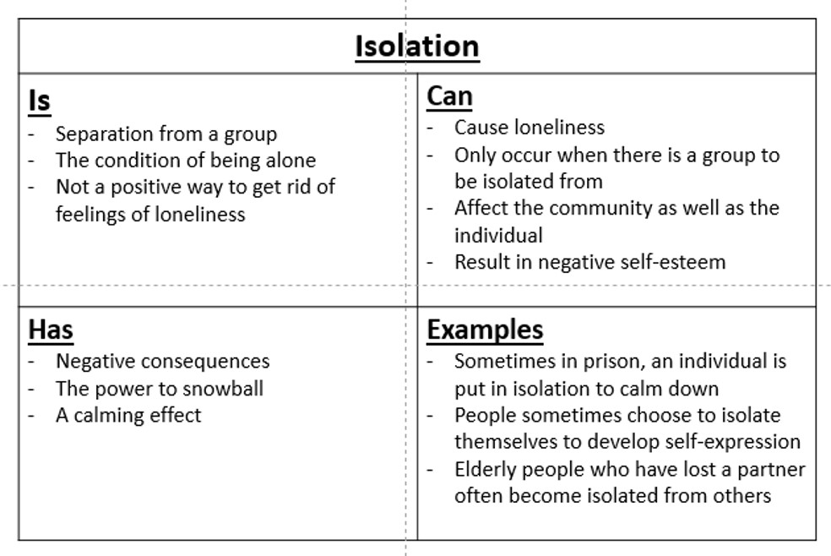
http://misslawler2.weebly.com/concept-frames.html
My concept frame is about……..
Is… | Can…
Has… | Examples…

