Genesis Potini by Desmond Rooplal
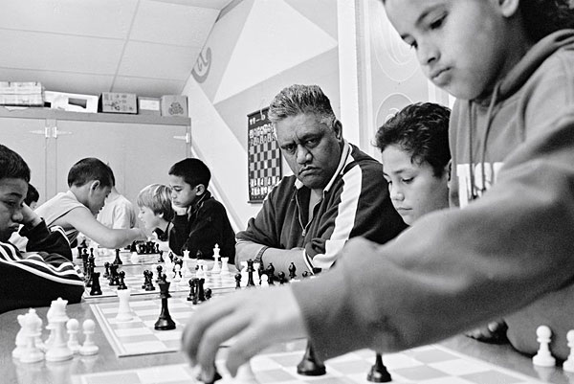
Genesis Potini had a remarkable impact through chess on those around him, and this legacy was so great that it merited making a movie to tell his story. With this in mind, I decided to research more about Potini, as a result I got in touch with Noble Keelan, via the Gisborne Eastern Knights President Colin Albert. Keelan it turns out, was Potini’s right hand man.
Gen “da man” Potini (as he is lovingly referred to by his colleagues from Eastern Knights Chess Club) in real life was not academically inclined. However he was highly intelligent and knowledgeable on a wide variety of subjects, along with being trilingual (Maori, English and Chinese).
Keelan, co-founder of Eastern Knights, on how he met Genesis: “I remember Gen from my childhood. We grew up in the same neighbourhood but didn't really know each other. He was someone to fear. He was known then as Tonto. I met Gen, properly when I was 16. After meeting him, he politely excused himself and walked over and beat someone up. I headed off in the other direction deciding I never wanted to know this person”.
Some 15 years later, guided by a mutual friend to Keelan, Genesis found a chess sparring partner. Keelan: “He had stayed locked away from society for a year from what he told me. The state he came to me in: was a very down and depressed man, but wanting a game of chess. From there he wouldn't go away (lol). We would play chess from 5 a.m. to about 1 a.m. (yes from 5 a.m. right through the entire day) the next morning. Sometimes even later, sometimes all night. He loved chess with a passion.” Talking to Keelan, I had to ask if this was an exaggeration in the movie, when Genesis shows up at 4:30 in the morning, to which Keelan replied after a short moment of silence: “all the bloody time Des!” and laughed.
Keelan on how it started: “At first it was for selfish reasons and he admitted this on many occasions. He believed the only way for him to get better at chess was to teach people to play, become as good as him so that his game could get better. You could only get stronger if you had strong opponents. When we started teaching kids, at first our target was Maori kids only, to show that Maori are brilliant too. He started to see the passion in the kids for the game. Gen saw the achievements and success in their education. Now he became passionate to teach not only Maori, but any child who was willing to and wanted to learn about and how to play chess. He marvelled over it.
He then saw that the kids with ADHD, dyslexia or problem children would just settle in and play this game, because it is just a game to kids. They started to benefit from it. He decided to target those kids as well. Teachers and principals to this day don't understand or believe that we want to have these kids in our classes. And after seeing it with their own eyes, they still find it hard to believe”.
The collateral effect of chess helping children improve their academic performance isn’t depicted in the movie The Dark Horse, but this was in reality one of the major effects that Genesis and Jedi had with children that performed poorly in school. In this way The Dark Horse does not exaggerate that Potini had a life-changing impact on children he reached out to, and as such is not merely a text book example of a coach/hero leading a bunch of misfits to a championship.
Genesis Potini was the real deal (Keelan: “We didn't call him ‘Gen Da Man’ for nothing.”) I asked Keelan whether this was an exaggeration and whether Michael burnt the school down, Keelan replied: “I can't remember how long their training was, but it wasn't long... a matter of weeks. And that would have been after school and weekends. And you have to remember with Gen being bipolar, he didn’t do things by halves! He near on expected perfection, and a lot of what he did was spare of the moment stuff. In real life you would look at him and see that he was the only one that didn't know it was unrealistic. You know it Des: Mike really did!” (burn down the school, accidently while playing a prank when he was eight).
As his character is portrayed in The Dark Horse, Potini did use Maori mythology to teach chess, along with many other analogies from life.
Keelan on Cliff Curtis taking the role of Potini: “What Cliff had to work with, where Gen was concerned, was near on absolutely nothing. So we all salute him for what he did. Cliff told us that there was no way he could do Gen justice. He believed Gen was bigger than life. But said he would play a version of Gen he thought he knew. What Cliff did was amazing, but it was a quiet Genesis. His transformation into Gen was mind blowing. To the extent it was invasive for me. It was more than the transformation. It's like Gen was there guiding Cliff. Things Cliff did, Gen did. There was no way on earth Cliff should of known those things. Personal things that no one knew about, except us. It made the hair on the back of your neck stand. That’s what Cliff gave to us. A second chance to be with Gen. A chance to hug Gen again. A chance to say goodbye. For me, I appreciate that more than what the film gave. Cliff gave more to us than a version of Gen in a film. The film is brilliant, but Cliff is da man! Mauri Ora Cliff!”

Gisborne Eastern Knights
The Eastern Knights was founded in 2000 by Potini and Keelan. When the Gisborne Chess Club (which was over 100 years old) folded in 2008, their equipment was donated to Eastern Knights, which saw an amalgamation of the two clubs. The result was Gisborne Chess Club survived it's over 100 year heritage through Eastern Knights, in the form of Gisborne Eastern Knights.
Gisborne Eastern Knights does not charge any membership fees to its members and is open to anyone interested in playing or learning how to play chess. Four of the club’s members put time into coaching the children and teaching basic chess to new members.
When Gisborne Eastern Knights runs a school tournament, they have an amazingly unique entry fee: they don't charge monetary entry fees for the tournaments, the children enter the tournament by “paying” canned food as the entry fee! The tournament organizers then take the collection of canned food to the "Food Bank", which in turn redistributes the food to those who cannot afford it, for free. Keelan said they do this to teach the kids that just as the tournament organizers give their time to chess, they want the children to learn to give back to the community.

Web address of original article:
http://en.chessbase.com/post/genesis-potini-kia-ora-tautini-tonu-te-kingi
Cut out of article
Potini did train Michael Manihera (who in the movie burnt down the school) and three other children, and Manihera (who was already a good club player) did win the Youth Championship with only several weeks of training.

